**Introduction SAP BI**

**Details**

Last Updated: Friday, 05 August 2016 07:08

Business intelligence (BI) is an application used for giving meaning to raw data that an organization has. The raw data is cleansed, stored and applied with business logics to be useful for enterprise users to make better business decisions. This data can be presented in the form of reports and can be displayed in the form of tables, charts etc. which is efficient and easier to analyse and make business decisions.

During all business activities, companies create data about customers, suppliers and internal activities. Based on these data’s, employees of various departments like HR, Finance, Accounting, Marketing etc. prepare their work plan.

Business Intelligence spans a varied set of toolset, of which the Data Ware House consolidates and loads the data from the different Source Systems, while reporting tools like Query Designer, Web Application Designer, and Analyzer are majorly used to create reports which display the data consolidated by the Datawarehouse for analysing purpose.

Business Intelligence is a SAP product which majorly focuses on providing its customers/organizations with a user friendly and very useful form of representing data that could be helpful for analyses purpose and making business decisions.

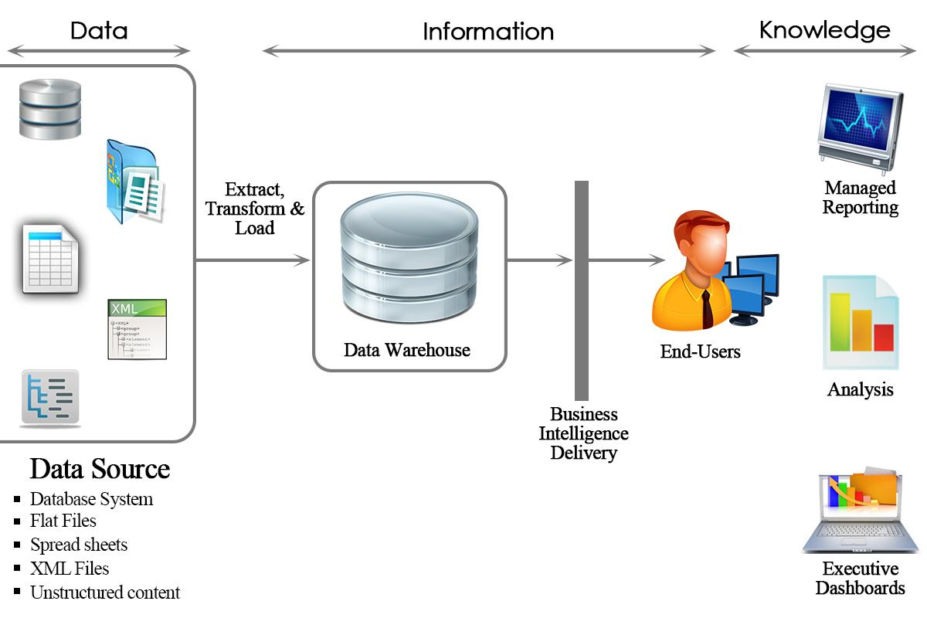

In summary, Business Intelligence tools transform raw data into reports which used for decision making and business forecasting.

**Why do we need Datawarehouse & BI ?**

Organizations have different kinds of data such as finance, Human resource, customer, supplier data etc., which can be stored on different kinds of storage units such as DBMS, excel sheets, SAP R/3 systems etc...Even the company's internal data is often distributed across many different systems and is not particularly well formatted.

[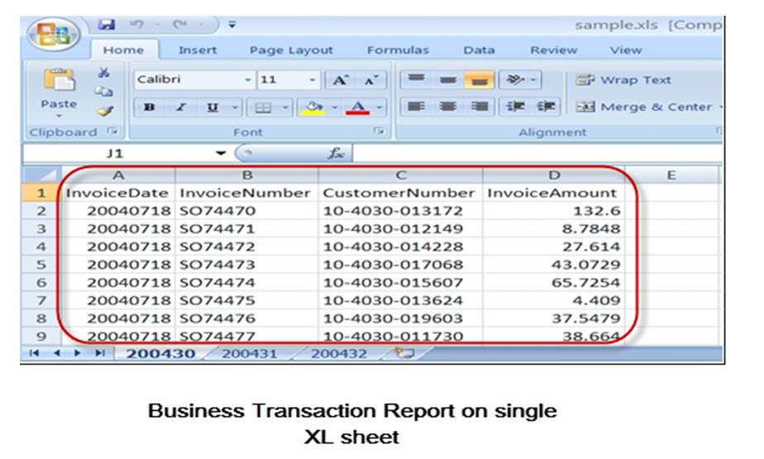](http://cdn.guru99.com/images/sap/SAP_BI/sap_bi_1_2.jpg)

A Data Warehouse can help to organize the data. It brings together heterogeneous Data Sources which are mostly and differing in their details. Using BI Tools one can derive meaningful reports

**What makes SAP BI more effective BI tool?**

* Single point of access to all information is possible through BI. The data from various sources can be accessed at the single place(i.e BI).
* Data collected from various sources are presented in the form of reports which is efficient for analysis of the data at a high level.
* SAP BI provides easy to use GUI and better formatting
* Some of the key functionality that makes SAP BI better than rest is its ability to analyze **multidimensional** data sources in both web and MS office environments, flexible dashboards, mobility and a flexible, scalable BI platform.
* SAP BI is known for its awesome **query performance**, while requiring little administration
* **Mobile BI** for end users on the go
* **Easy Integration** with other platforms

**SAP BI/ Data Warehouse Vs. OLTP systems:**

**OLTP(Online Transaction Processing):**

These systems have detailed day to day transaction data which keeps changing. For example, R/3 or any other database.

**OLAP(Online Analytical Processing):**

These systems have data for analysis purpose. The input for this system is from OLTP systems. The data from the OLTP systems is made use to prepare the data for analysis purpose.

Business Intelligence is an OLAP system.

|  |  |  |
| --- | --- | --- |
|  | **OLTP Systems** **(Operative Environment)** | **DWH/OLAP Systems(Informative Environment)** |
| Target | Efficiency through automation of business processes | Generating Knowledge (Competitive Advantage) |
| Priorities | High availability, higher data volume | Simple to use, flexible access to data |
| View of Data | Detailed | Frequently aggregated |
| Age of Data | Current | Historical |
| Database operations | Add, Modify, delete, update and read | Read |
| Typical data structures | Relational(flat tables, high normalization | Multidimensional Structure |
| Integration of data from various modules/applications | Minimal | Comprehensive |
| Dataset | 6-18 months | 27 years |
| Archiving | Yes | Yes |

**Overview of SAP BI Architecture**

**Details**

Last Updated: Sunday, 04 September 2016 16:00

Before we learn more about SAP BI Architecture, lets learn about

**Conceptual Layers of Data Warehousing with BI**

[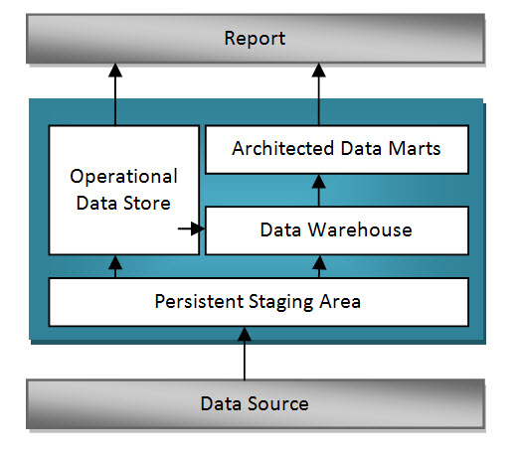](http://cdn.guru99.com/images/sap/SAP_BI/sap_bi_2_1.jpg)

**Persistent Staging Area**

The data extracted from the Source Systems first enters into the Persistent Staging Area. The data at this layer is the raw data which is in unchanged form. The data is consolidated and cleansed only in the next layers.

Staging area is a temporary table that holds the data and connects to work area or fact tables.  In the absence of staging area the data load will have to go from the OLTP system to the OLAP system directly which hamper the performance of OLTP system.

**Data Warehouse Layer (DWH Layer)**

Data from the Persistent Staging Area is loaded into the DataWareHouse Layer. It has Corporate information repository. Data in this layer is stored for a longer period.i.e,Entire History data (for example, last 5 years data) is stored here in this layer.No aggregation of reporting-relevant data;the granularity of the data stored in this layer is at line-item (detailed) level.

**Operational Data Store Layer**

Data is loaded to an Operational Data Store Layer very frequently on a continuous basis from the source systems. Hence the data in this layer contains all the changes to the data that was done throughout the day. Data from Operational data store later can be loaded to the Datawarehouse layer at particular timings (say end of the day) to update the date in Datawarehouse Layer. This Operational Data Store Layer can also be used in case of any emergencies when the data in the datawarehouse and datamart layers are lost. In such situations data can be loaded from the Operational Data Store layer to the Data Warehouse Layer and Data Mart Layer. ODS is not based on star schema model but they are in a flat files format.

**Architected Data Mart Layer**

Architected Data Mart Layer also known as Infocube. It is designed to store summarized and aggregated Data for long period of time.  Data from the Data Warehouse Layer is loaded into the Architected Data Mart Layer. It is used in Analysis and reporting. The data is at a high level relevant for creating reports displaying these data. Data manipulation with business logic is done at this layer. It consists of a central fact table(Key Figures) surrounded by several dimension tables, it is used to support BI queries

**Key Components of SAP  BI System:**

Business Intelligence is a core component of SAP NetWeaver. The figure below shows the key components of a BI system.

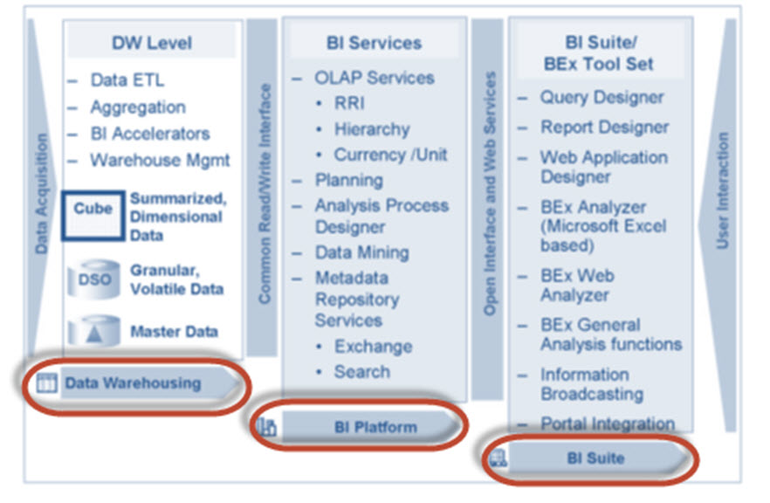

* ***Data warehousing*** – This is mainly to Extract, Transform and Load data from Source systems.
* ***BI platform*** – The BI platform layer contains BI services to support complex analysis tasks and functions. It contains the Analytic Engine, which processes the data requested through BEx analysis navigations. Its interface allows entry and manipulation of data as part of BI Integrated Planning. It also has special analysis tools such as the Analysis Process Designer (APD) and the Data Mining which provide analysts at your company with the tools to merge, mine, pre-process, store, and analyse data.
* ***BI Suite*** – These tools helps in creating reports for analysis purpose.It contains the Business Explorer (BEx) which provides flexible reporting and analysis tools.

            The following areas in the Business Explorer can be used for Data Analyses:

1. BEx Analyser (Microsoft Excel-based analysis tool with pivot-table-like features)
2. BEx Web Analyser (Web-based analysis tool with pivot-table-like features)
3. BEx Web Application Designer (customer-defined and SAP BI Content provided)
4. BEx Report Designer (highly formatted Web output)

**SAP BI Architecture:**

BI has three tier architecture:

**Database Server:**Where data is physically stored.( ODS, PSA, Infocube and metadata repository).

**Application Server:**The application server is based on the OLAP processor. It is used to retrieve data stored in the database server.

**Presentation Server:**Manages reporting and data access.

1. Data is extracted from the Source Systems.
2. Data is staged at the Persistent Storage Area(PSA). This holds Source like data.
3. Data is cleansed, loaded and stored in Data Store Object.
4. Data is viewed at multiple dimensions in the Infocube.
5. Data is available by the OLAP processor to the Business Explorer to display data as per Analysis requirements of the Business.
6. Data can be made available to SAP/Non-SAP, Data Marts by the Open Hub Service.( InfoSpoke).

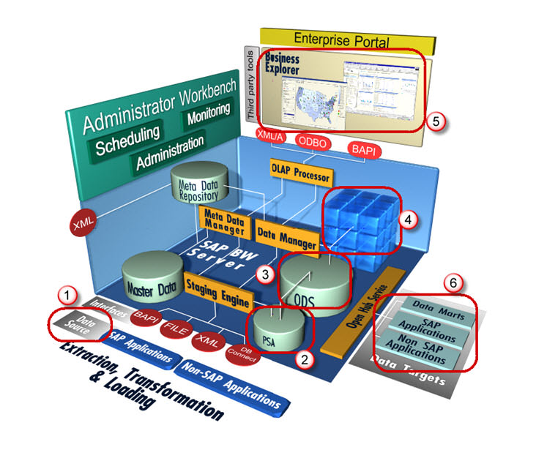

**All About Infoobject Infoarea & Infoobject Catalog**

**Details**

Last Updated: Sunday, 04 September 2016 16:00

**What is an InfoObjects?**

Info-Objects take information from the source, then adjust and arrange the information into either a standard or customized report.  Infoobjects are the smallest available information modules/fields in BI. **It is needed in info-providers like InfoCubes, DSOs, MultiProviders, Queries etc...  These Info-Providers are made up of Info-objects.**

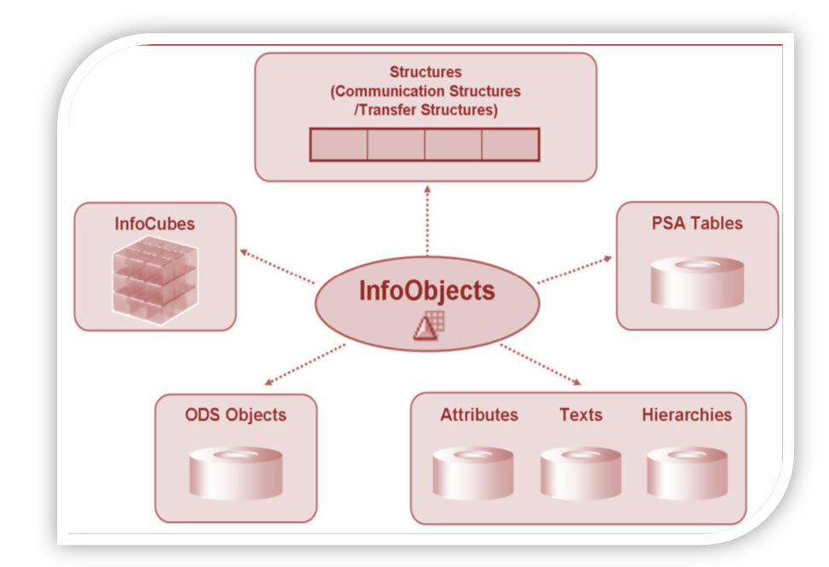

Info-object gives all information about the business. For instance company ‘XYZ’ is interested in finding out how much of “product x” shipped on “date x” to “factory x”.  By defining Info-object for specific function like “0MATERIAL”, “0DATE” and “0LOCATION” all the information can be retrieved.

InfoObjects can be classified into the following types:

* Characteristics (for example, customers)
* Key figures (for example, revenue)
* Units (for example, currency, amount unit)
* Time characteristics (for example, fiscal year)
* Technical characteristics (for example, request number)

**Characteristics:**

Characteristics are Business reference objects used to analyze key figures.

Examples of characteristics InfoObjects:

* Cost center (0COSTCENTER)
* Material(0MATERIAL)

**Keyfigures:**

Key figures provide the values to be evaluated. They are numeric information that is reported in the query.

Examples of key figure InfoObjects:

* Quantity (0QUANTITY)
* Amount (0AMOUNT)

**Units:**

Units are paired with Key figure values . They provide assign a unit of measurement to a Key Figure Value. For instance 10 Kg where 10 is the KeyFigure and Kg is the unit

Other Examples of Unit Characteristics:

* Currency unit (0CURRENCY) (Holds the currency type of the transaction e.g. $, EUR, USD...)
* Value unit (0UNIT)  (or) unit of measure (Hold the unit of measure e.g. Gallon, Inch, cm, PC)

**Time Characteristic:**

Time characteristics give time reference to data.

Examples of Time Characteristics:

* Calendar day (0CALDAY)
* Calendar year (0CALYEAR)
* Fiscal year (0FISCYEAR)

**Technical Characteristics:**

Technical characteristics are SAP standard objects having their own administrative purposes.

Examples of Technical Characteristics:

* Info Object 0REQUID – While loading data to various data targets,  SAP allocates unique numbers which are stored in this Info object
* Info Object 0CHNGID – When aggregate change run is done, a unique number is allocated and stored in this info object.

**Before creating an Info Object, Info Area and Info Object Catalog need to be created.**

**What is an InfoArea?**

* In Business Warehouse, Info-areas are the branches and nodes of a tree structure.
* It is used to organize info cubes and info objects.
* Each Info-object is assigned to an Info Area.
* Info Area can be thought of as a folder used to hold related files together.

**What is Infoobject Catalog?**

* Every info object need to be created within an Info Object Catalog.
* It helps in organization and is no way related to reporting functions.
* Example: There are tons of InfoObjects for SAP Financials which can be clubbed into a InfoObject Catalog.  This makes management and maintainence easy.
* An Info Object can be assigned to multiple Catalog

There are 2 types of Info Object Catalog.

1. Characteristic Info Object Catalog
2. Key figure Info Object Catalog

**Here is the RoadMAP to create an Infoobject**

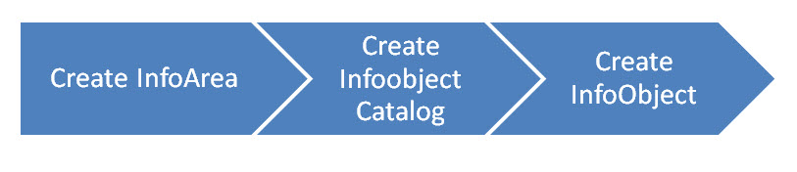

**How To Create an Infoarea?**

**Details**

Last Updated: Sunday, 04 September 2016 16:00

**Step 1)**

1. Go to transaction code RSA1 to go to the Data Warehouse Workbench.
2. Click the OK button.

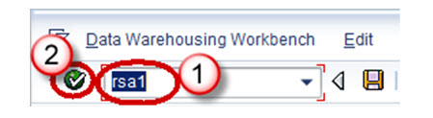

**Step 2)**

1. Navigate to Modeling ->InfoProvider
2. Right click in the Workbench and Create an InfoArea

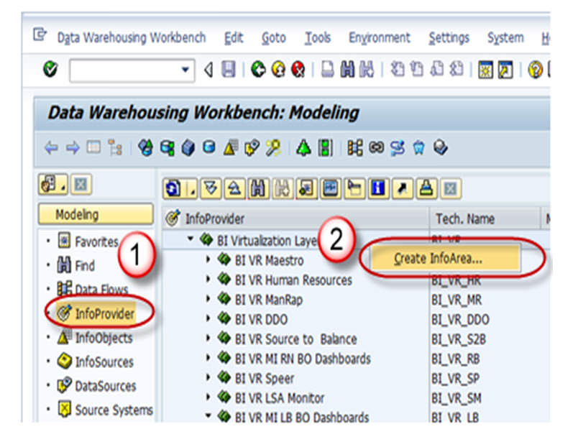

**Step 3)**

1. Enter the Technical Name
2. Enter the Description
3. Press the enter button

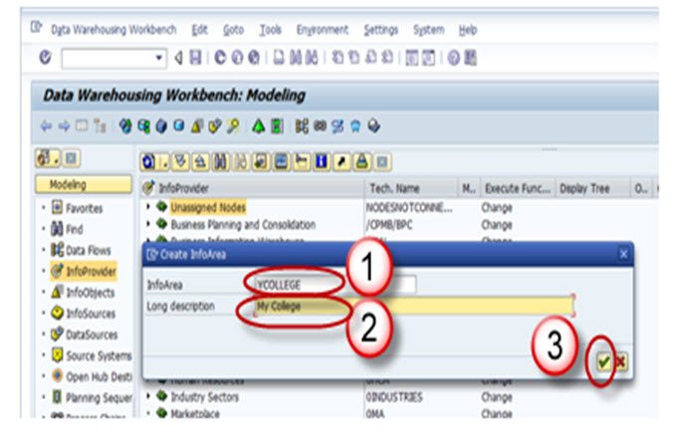

**Step 4)**

The Info Area created appears as shown below.

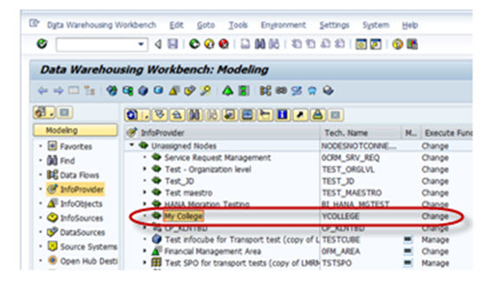

**How To Create an InfoObject Catalog**

**Details**

Last Updated: Sunday, 04 September 2016 16:00

**Step 1)**

1. Go to transaction code RSA1 to go to the Data Warehouse Workbench.
2. Click the OK button.

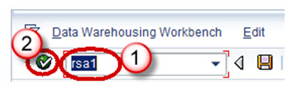

**Step 2)**

1. Navigate to Modeling -> Infoobjects
2. Right click on the Info Area and choose the option “Create InfoObject Catalog” as shown below

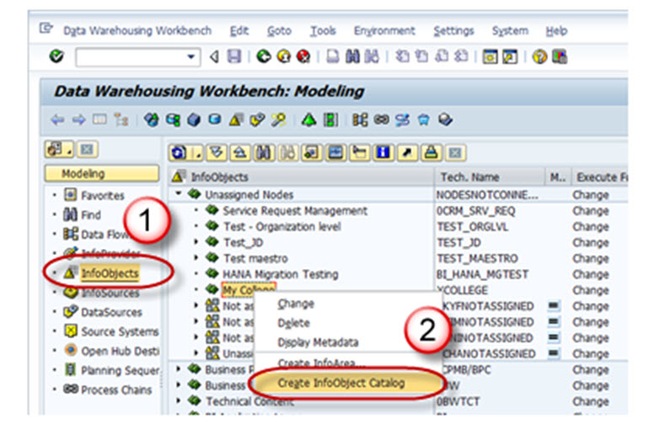

**Step 3)**

1. Enter the Technical name of the InfoObject Catalog.
2. Enter the Description of the InfoObject Catalog.
3. Click in the “Characteristic InfoObject” option button. This is a characteristic InfoObject Catalog. Click the Keyfigure option button. Then a Keyfigure InfoObject Catalog would be created.
4. Click on the create button.

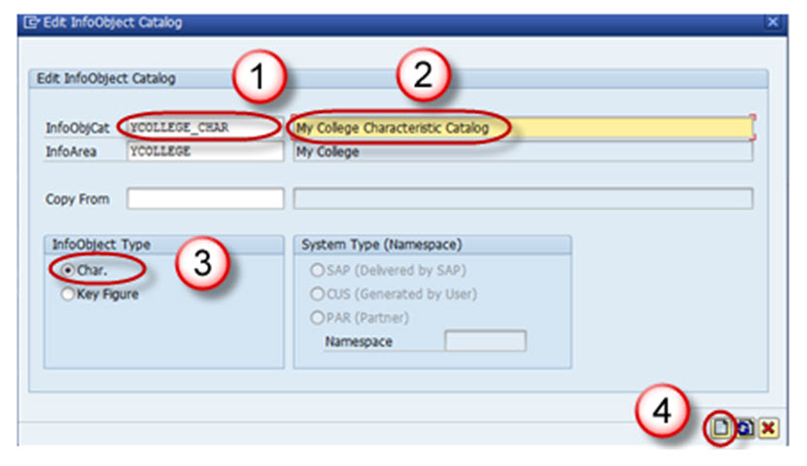

Save and Activate the InfoObject Catalog. The InfoObject Catalog created appears as shown below.

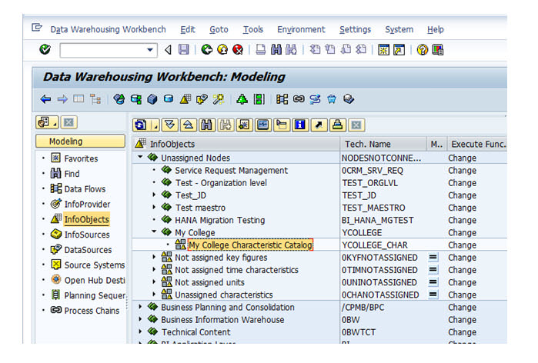

**How To Create an InfoObject with Characteristics**

**Details**

Last Updated: Sunday, 04 September 2016 16:00

**Step 1)**

1. Go to transaction code RSA1 to go to the Data Warehouse Workbench.
2. Click the OK button.

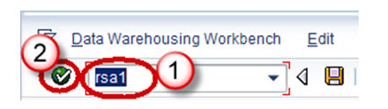

**Step 2)**

1. Navigate to Modeling -> Infoobjects
2. Right click on the Characteristic InfoObject Catalog and choose the option “Create InfoObject” as shown below.

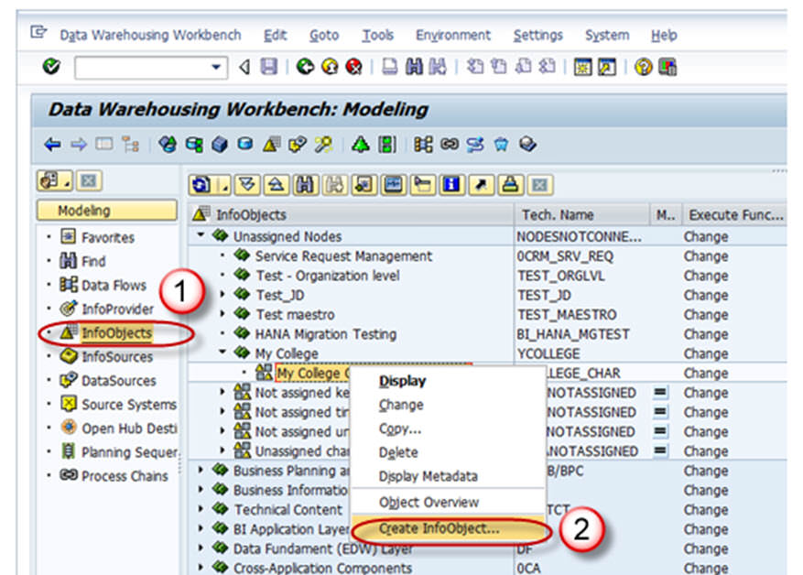

**Step 3)**

1. Give Technical name of the characteristics
2. Give a meaningful Description
3. Reference Characteristics is mentioned if the new characteristic to be created has the same technical properties of some other already existing characteristic.( LCOSTC)
4. Template is specified if the new characteristic to be created has some of the technical properties of an already existing characteristic. (LCOSTC)
5. Hit the enter button.

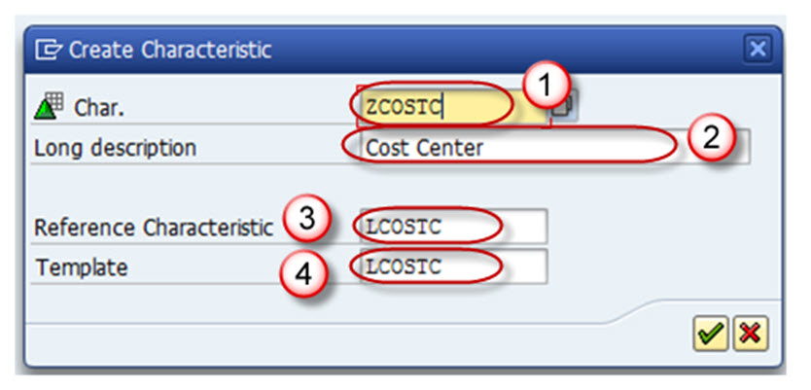

On completion of the above step, it takes you to the “Edit Screen” of the Infoobject. The Infoobject “Edit Screen” has 6 Tab pages listed below.

1. General
2. Business Explorer
3. Master Data/Texts
4. Hierarchy
5. Attribute
6. Compounding

Let us see each of the tab pages individually.

**Tab Page: General**

In this Tab Page, enter the following

1. The Technical name of the InfoObject
2. Enter the long and Short description
3. Enter the data type
4. Enter the length.

All other settings in this tab and other tabs are optional.

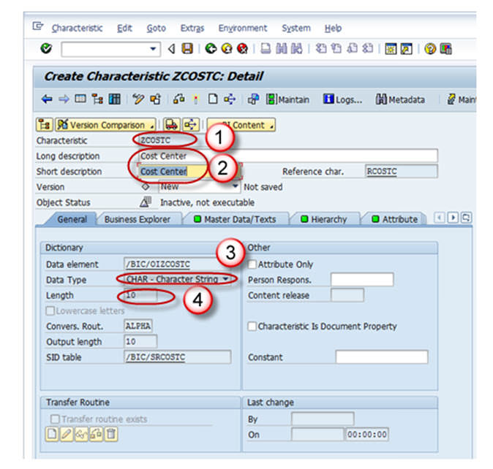

**Tab Page: Business Explorer**

1. Each and every setting in the Business Explorer tab page is to set default values in the Business Explorer.
2. The Display:”Text” setting on this page decides whether the value of the characteristic is displayed as a textual description or as a key in the Business Explorer.

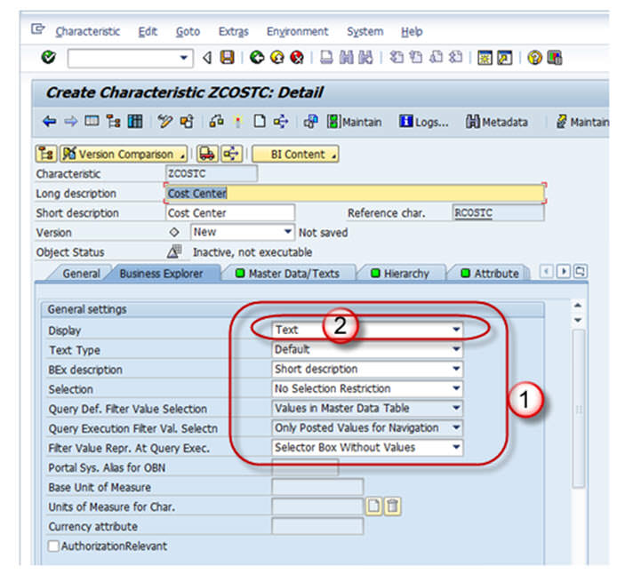

**Tab Page: Master Data/Texts**

1. The Check box “With Master Data checkbox” and/or “With Texts” has to be selected for Master Data bearing Infoobject. By selecting any of these checkboxes, the characteristic is designed to bear master data and it has its own master data tables.
2. If the characteristic needs its own texts, you need to make at least one text selection. The text can be short, medium or long text with 20, 40, or 60 characters respectively.

In the screen shot shown below, the Characteristic has master data table(With master data check box is checked) but does not have Text table(With Texts is unchecked).

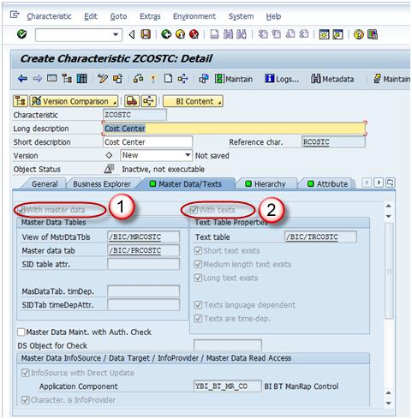

**Tab Page: Hierarchy**

A hierarchy indicates a parent-child relationship which consists of several nodes and leaves.

On the Hierarchy tab page, you determine whether or not the characteristic can have hierarchies and, if so, what properties these hierarchies are allowed to have.

If the **“With” hierarchies** checkbox is checked, hierarchies can be created for this characteristic. In the below screen shot, the check box is unchecked, hence no hierarchy is created for this info object.

Hierarchy can be created manually or loaded from the SAP system or other non sap source systems. Hierarchy can be used to drill down or extract specific information about the business item.

Example: A real time scenario when Hierarchy can be used is as follows,

Assume in the case of a bank, the relationship between the main bank and the various branches under a bank can be maintained in the form of hierarchy. Where you can extract the information of customer details at any branch about its account, loan, due dates for loan payment and so on.

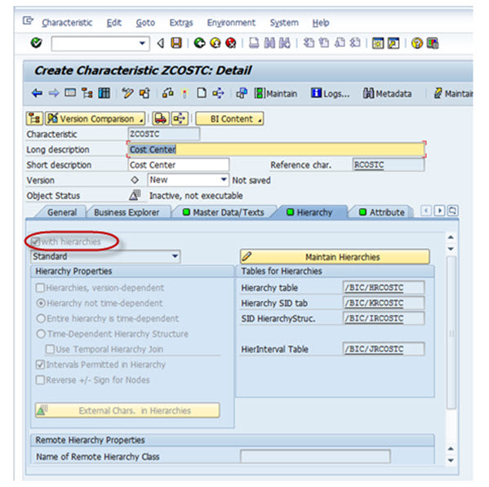

**Tab Page: Attributes**

Attributes are nothing but the fields or properties of master data, there are different types of attributes like display attributes, navigational attributes, executive attributes, compound attributes and so on.

1. You determine whether or not the characteristic can have attributes or texts. The attributes are assigned to the characteristic on the *Attributes* tab page. *Several characteristics can be added as attributes of the master data characteristics in the Attribute tab page.*
2. *Attributes can be marked as navigational or display attribute by clicking on “navigational attribute on/off” button.*

* If you define attributes as **display attributes**, you can use these attributes only as additional information in reporting when combined with the characteristic.
* If you define attributes as **navigation attributes**, you can use them to navigate in reporting. When a query is executed, the system does not distinguish between navigation attributes and characteristics for an InfoProvider.
* In the example below, company code is navigational.

1. Display and navigation attributes can be marked as **time-dependent** if a validity period is required for each attribute value.

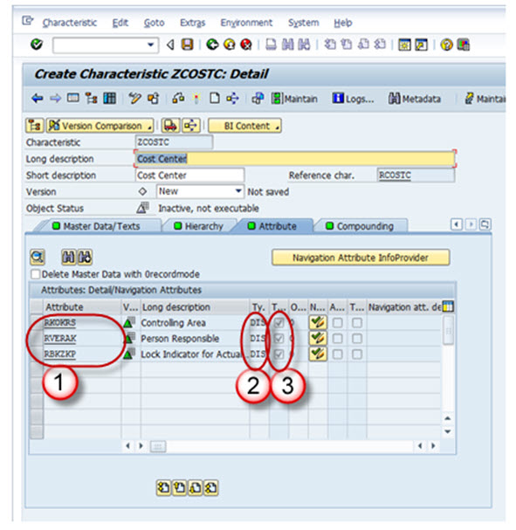

**Tab Page: Compounding**

On this tab page, you determine whether or not the characteristic is to be compounded to other InfoObjects. You often need to compound characteristic values to enable characteristic values to be uniquely assigned. Some Info-objects cannot be defined without compounding, also in order to map the data-model you have to compound Info-Objects sometime. If the info-object is defined as an attributes, it cannot be included as compounding object.

Say, for example, cost center 1000 stands for sales and distribution in controlling area 10, and it also stands for sales in controlling area 20. In this case, you would define a cost center to controlling area characteristic Compounding.

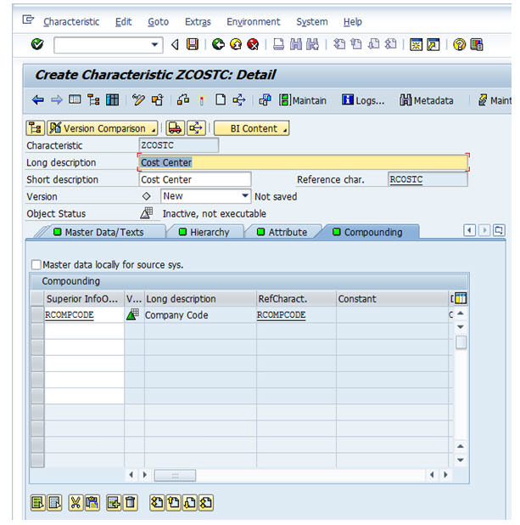

Now save and Activate the Infoobject.

**How To Create InfoObjects With Key Figures**

**Details**

Last Updated: Sunday, 04 September 2016 16:00

Go to RSA1 -> Modeling ->Infoobjects

Right click on the Infoarea -> Click on Create Infoobject catalog for Key Figures. Activate the Keyfigure Infoobject Catalog.

Now Click on Infoobjects catalog -> Create Infoobject

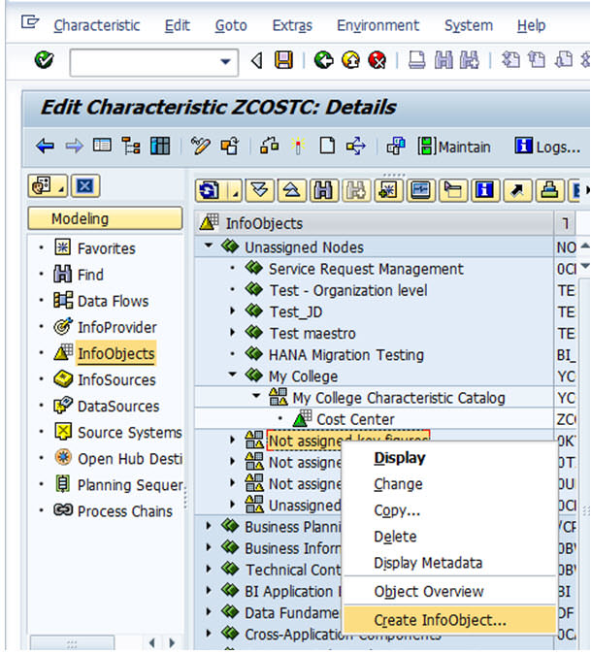

1. Give Technical name of the Keyfigure.
2. Give a meaningful Description
3. Reference Keyfigure is mentioned if the new Keyfigure to be created has the same technical properties of some other already existing Keyfigure. In this case the already existing Keyfigure(Technical name is mentioned here).
4. Template is specified if the new Keyfigure to be created has some of the technical properties of an already existing Keyfigure. In this case the already existing Keyfigure (Technical name is mentioned here).
5. Hit the enter button.

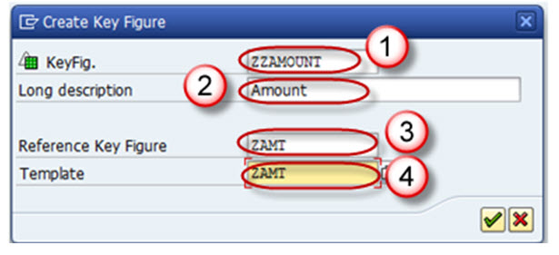

On completion of the above step, it takes you to the Edit screen of the keyfigure Infoobject. The keyfigure Infoobject Edit screen has 3 Tab pages listed below.

1. Type/unit
2. Aggregation
3. Additional Properties

Let us see each of the tab pages individually.

**Tab Page: Type/unit**

1. On this tab page, you determine the key figure type (amount, quantity etc), the data type and the currency/quantity unit.
2. If you choose key figure type amount or quantity, you must assign a currency or quantity unit to this key figure.
3. For key figure type Amount, you can choose between a fixed currency (USD, for example) or a variable currency, (0CURRENCY, for example).
4. For key figure type Quantity, you can choose between a fixed quantity unit such as KG, or a variable quantity unit such as 0UNIT.

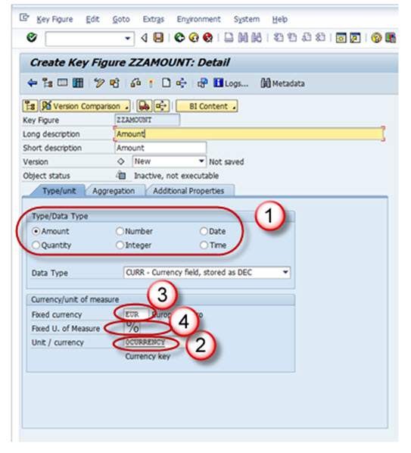

**Tab Page: Aggregation**

An aggregate is a materialized, summarized view of the data in an Infocube. In other words, it consolidates and stores a subset of infocube data into a database.  When query is executed on an infocube with appropriate aggregates the query reads the summarized data directly from the database. It is also referred as baby-cube of Info-cube.  It is recommended to use aggregates, if an infocubes contains lots of data.

Aggregation rules are set on this tab page for the key figure's behavior when data gets stored in tables in BI and in BEx reports.

1. **Aggregation**

In the Aggregation field, you specify the function (SUM/MAX/MIN) that determines the way in which the key figure is aggregated.

1. **Exception Aggregation**

In the Exception Aggregation field, you specify the function (last value, first value, max, or min) that determines the way in which the key figure is aggregated using the reference characteristic for exception aggregation in the Business Explorer.

1. **Reference Characteristic for Exception Aggregation**

In the Reference Characteristic for Exception Aggregation field, you choose the characteristic with reference to which the key figure is aggregated with exception aggregation. Generally, this is a time characteristic.

1. **Cumulative/noncumulative values**

A noncumulative value is a non-aggregating key figure, on the level of one or more objects, that is always displayed in relation to time.

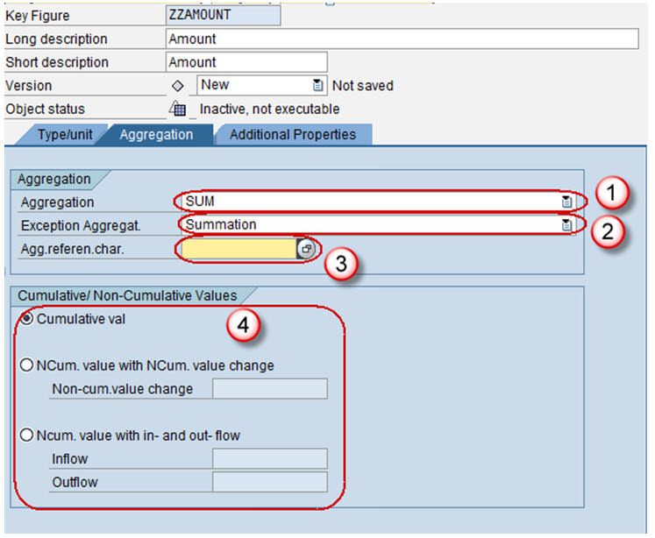

**Tab Page: Additional Properties**

1. This tab page is primarily used to change default settings for the key figure display type (number of decimal places, display scaling etc) in Business Explorer (BEx).
2. It also allows you to set Key Figure with Maximum Precision, which internally processes calculations involving this key figure with more decimal places, thus reducing rounding errors, but at the cost of reduced speed.

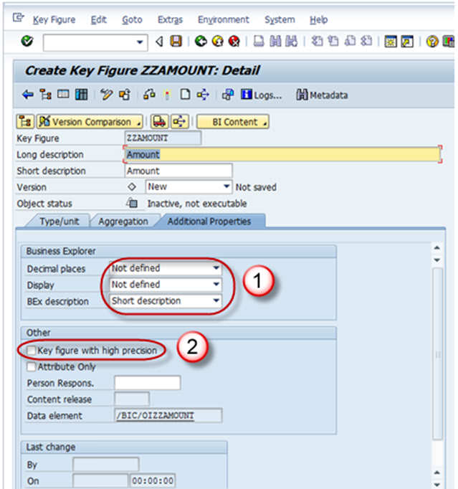

Finally Save and Activate Key Figure.

**What Is DSO? Why Use It?**

**Details**

Last Updated: Sunday, 04 September 2016 16:00

A Data Store object (DSO) is a two dimensional storage unit which mainly stores consolidated and cleansed transaction data or master data on a lowest granularity

* It is a two dimensional Transparent Table.
* Data is stored at detailed level.
* With DSO, it is also possible to overwrite data fields.
* Detailed level reporting can be obtained from a DSO.

**Why use DSO?**

Lets take an example of Sale order Data, which has to be extracted from SAP R/3 system(OLTP: Online Transaction Processing data which keeps changing) into BI. The Sales Orders created in the R/3 system could be edited at any point of time after creation of the record. Initially when sales order records are created in R/3, these records are extracted into BI. Once the records are changed in R/3, the changes need to be made in BI.

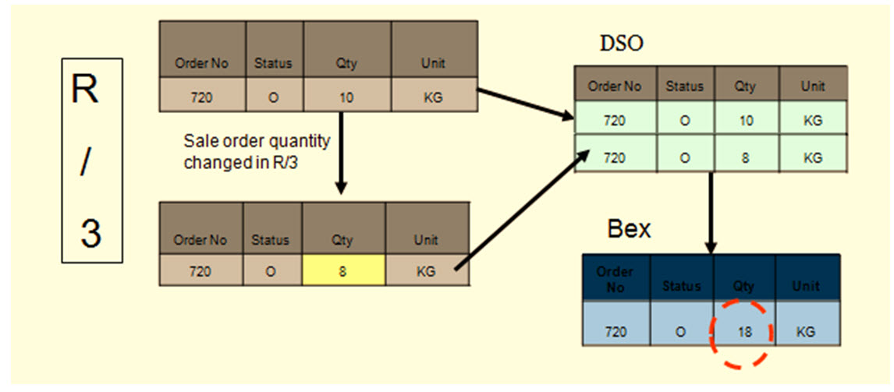

* Data is extracted from SAP R/3 system and loaded into Data Store Object.
* Initially, records are stored in New Status in the DSO. Records are stored in the New Table.
* Once the DSO data is activated, data is stored in the Active table.The New Table does not hold that data anymore.
* When records are changed in R/3, for these changes to reflect in BI, the changes are extracted into the DSO.
* Now the data is stored in the new table until the DSO contents are activated. The Data has to be further loaded into Info cube from which reports are being delivered.
* DSO has Overwrite and additive functionalities.If all characteristics are same, key figures are aggregated/overwritten based on the functionality chosen.
* Cube is additive in nature. If all characteristics are same, key figures are aggregated.

**Types of DSO**

DSOs can be classified into the following types:

1. Standard DSO
2. Direct Update DSO
3. Write-Optimized DSO

**What Is Standard DSO? How To Create One?**

**Details**

Last Updated: Sunday, 04 September 2016 16:00

A standard DSO has three transparent tables on the database.

1. **Activation Queue**: Holds the records that are to be updated, not yet been activated.
2. **Active Data:**Table which holds active data.
3. **Change Log:**Holds the change history for delta loads.

**Process of Data transfer to DSO**

* Data gets first loaded into the activation Queue also called the New data table.
* Dataupon “Activation” is transferred from New data table to Active data table
* And then to Change log table. In change log table you can have the changed data or corrected data.

Note: the data in Change log table is redundantly stored and can be deleted after the records have been activated.

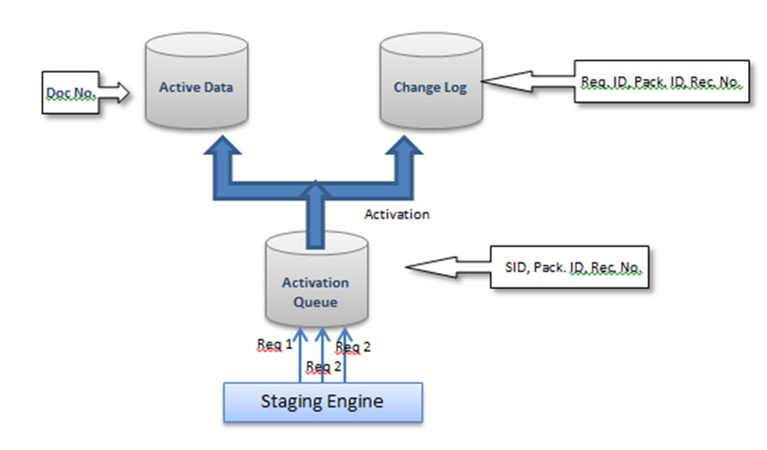

**Creation Of Standard DSO:**

**Step 1)**

1. Go to transaction code RSA
2. Click the OK button.

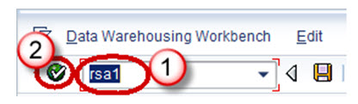

**Step 2)**

1. Navigate to Modeling tab->InfoProvider.
2. Right click on InfoArea.
3. Click on “Create DataStore Object” from the context menu.

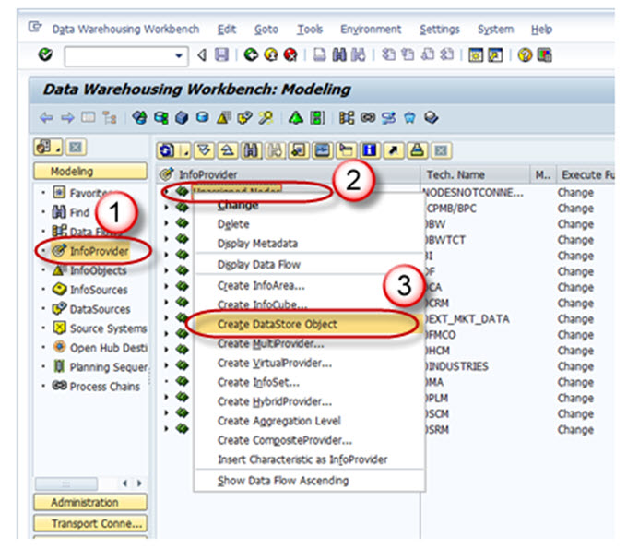

**Step 3)**

1. Enter the Technical Name.
2. Enter the Description.
3. Click on the “Create” button.

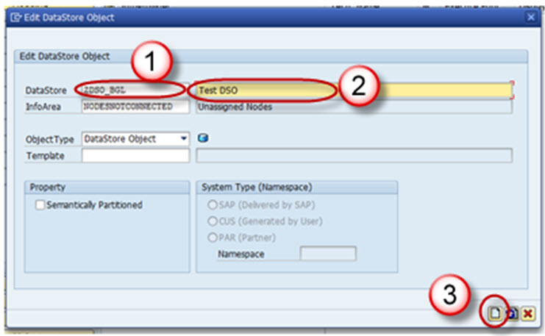

**Settings in DSO:**

1. Type of DataStore Object: This option can be used to change the type of DSO. By default, Standard DSO would be chosen. This can be changed to Write optimized or Direct Update DSO.
2. SID Generation upon Activation :Generated the Surrogate ID (SID) for each master data value, when this option is checked.
3. Unique Data Records:  This option can be used when the DSO will never hold duplicate values.
4. Set Quality Status to “OK” Automatically:  This setting sets the Quality status after the data loading has been completed.
5. Activate Data Automatically: DSO activation is automated by using this setting.
6. Update Data Automatically: Data loaded in the DSO can be automatically loaded to target objects using this setting.

**Including Key Fields and Data Fields in the DSO:**

DSO contains 2 kinds of fields

1. Key field
2. Data field

Key field is used to make the records unique. Other fields can be included as data fields in the DSO,

**Step 1)**

Right Click on “Key fields” and choose the option “InfoObject Direct Input”.

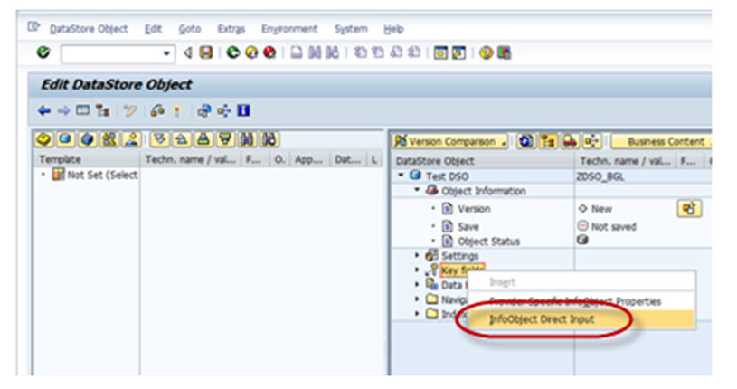

**Step 2)**

The following pop-up opens. Here you can input the technical names of the InfoObjects you have to include and press enter.

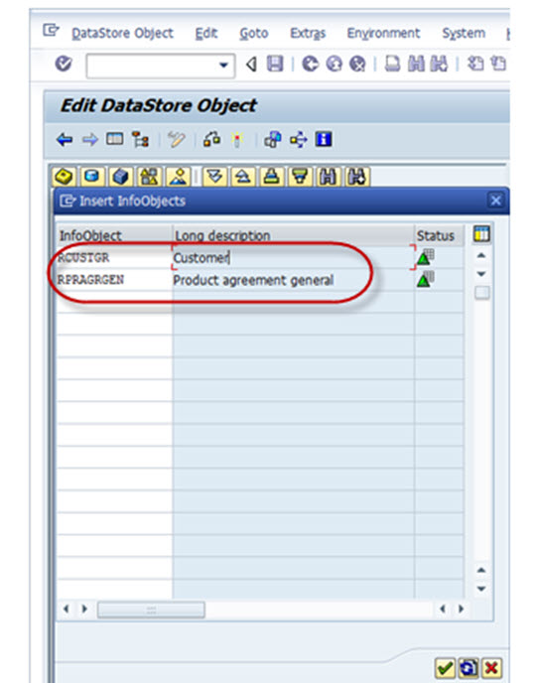

Below shown is the Keyfields added in the DSO.

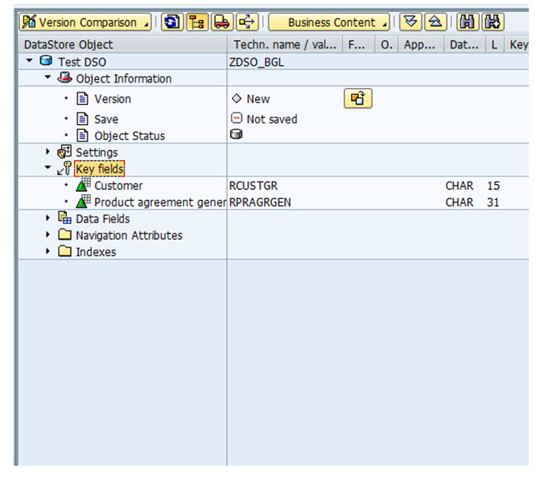

**Step 3)**

Navigational Attribute would be viewed in the DSO by default, but the check box to ON/OFF Navigational has to be chosen if it is to be used in reporting.

**Step 4)**

The DSO structure design is complete. Activate the DSO by clicking on the Activate button.

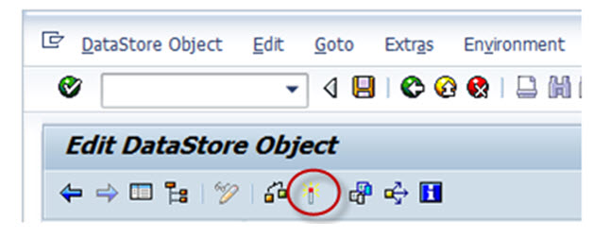

**What Is Write Optimized DSO? How To Create One?**

**Details**

Last Updated: Sunday, 04 September 2016 16:00

Write Optimized DSO is used when a Data storage object is required for storing lowest granularity records such as address and when overwrites functionality is not needed. It consists of the table of active data only, hence no need for data activation which increases data process. Data store object is available immediately for further processing; it is used as a temporary storage area for large set of data.

Write-Optimized DSO has been primarily designed to be the initial staging of the source system data from where the data could be transferred to the Standard DSO or the Info Cube.

1. PSA receives data unchanged to the Source system
2. Data is posted at document level**,** After loading in to standard DSOs data is deleted
3. Data is posted to Corporate memory write –optimized DSO from pass thru write-optimized DSO
4. Data is Distributed from write-optimized “pass thru” to Standard DSOs as per business requirement

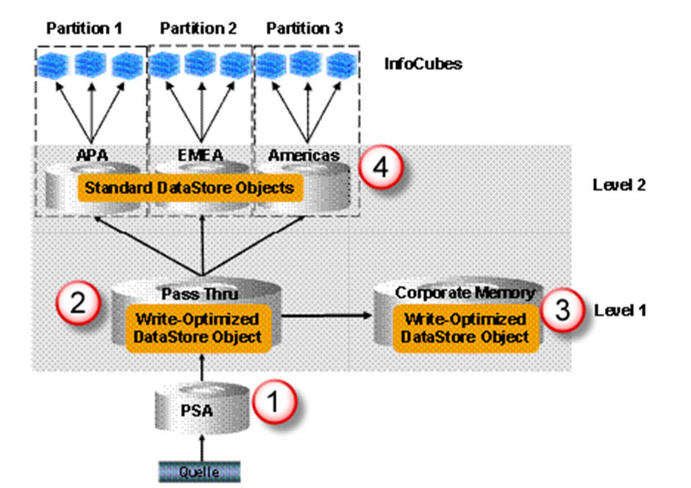

**Write Optimized DSO Properties:**

* It is used for initial staging of source system data.
* Data stored is of lowest granularity.
* Data loads can be faster since it does not have the separate activation step.
* Every record has a technical key and hence aggregation of records is not possible. New records are inserted every time.

**Creation Of Write-Optimized DSO:**

**Step 1)**

1. Go to transaction code RSA1
2. Click the OK button.

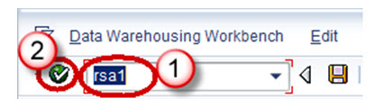

**Step 2)**

1. Navigate to Modelling tab->Info Provider.
2. Right click on Info Area.
3. Click on “Create Data Store Object” from the context menu.

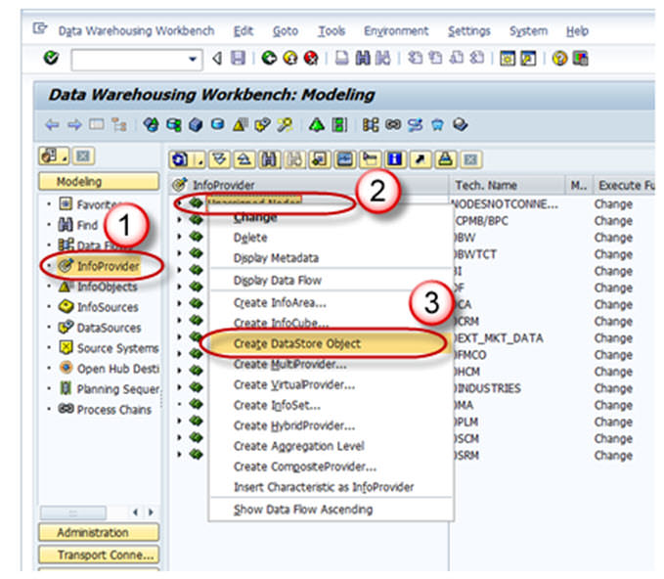

**Step 3)**

1. Enter the Technical Name.
2. Enter the Description.
3. Click on the “Create” button.

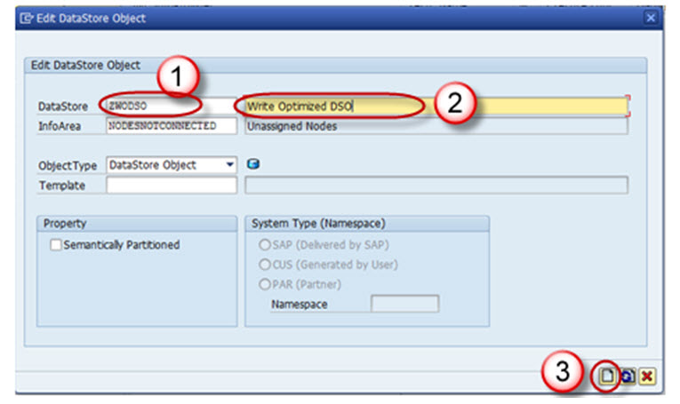

**Step 4)**

Click on the Edit button of “Type of DataStore Object”.

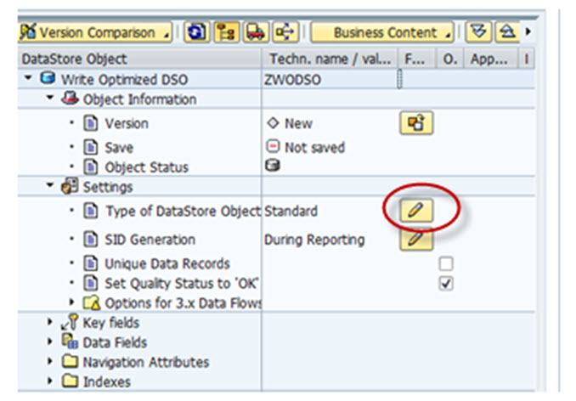

**Step 5)**

Choose the Type “Write-Optimized”.

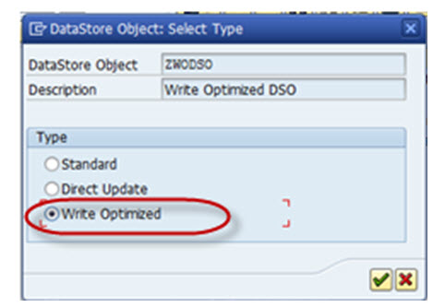

Technical keys include Request ID, Data package, Record number. No additional objects can be included under this.

Semantic keys are similar to key fields, however, here the uniqueness is not considered for over write functionality. They are instead used in conjunction with setting *“Do not check uniqueness of data”.*

The Purpose of Semantic Key is to identify error in incoming records or Duplicate records .

Duplicate Records are written into error stack in the subsequent order. These records in the error stack can be handled or re-loaded by defining Semantic Group in DTP.

Semantic Groups need not be defined if there will be no possibility of duplicate records or error records.

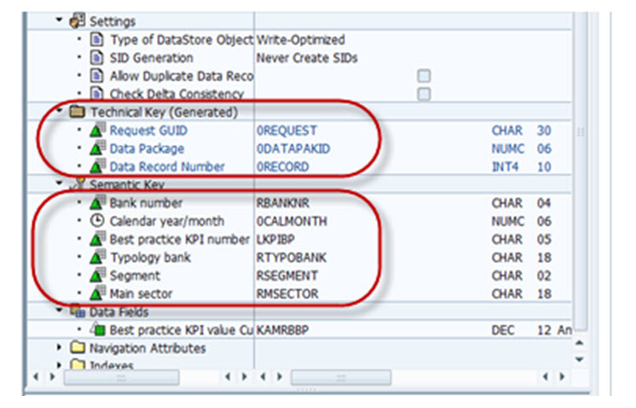

If we do not check the Check Box  “Allow Duplicate Data Record “, the data coming from source is checked for duplication, i.e, if the same record (semantic keys) already exist in the DSO, then the current load is terminated.

If we select the check box , Duplicate records are loaded as a new record. There is no relevance of semantic keys in this case.

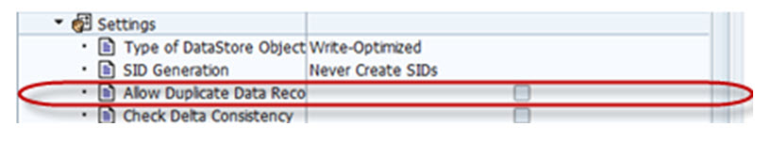

**Step 6)**

Activate the DSO.

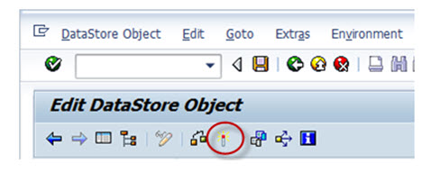

**What Is Direct Update DSO? How To Create One?**

**Details**

Last Updated: Sunday, 04 September 2016 16:00

Standard DSO differs from Direct update DSO in terms of how data is processed.

In Standard DSO, data is stored in different versions Active, Delta, Modified

whereas Direct Update DSO contains data in single version. Data is stored precisely in same form in which it is written to DSO consists of Active Data Table for direct update by the application. It retrieves its data from external systems via fill or delete APIs.

**The Following APIs exists:**

* RSDRI_ODSO_INSERT: This API is used to Insert new data which does not exist in the system.
* RSDRI_ODSO_INSERT_RFC: This is similar to the API “RSDRI_ODSO_INSERT” except that this API can be called remotely.
* RSDRI_ODSO_MODIFY:  This API is used to modify existing records. If a new record comes in, the record is inserted.
* RSDRI_ODSO_MODIFY_RFC: This is similar to the API “RSDRI_ODSO_MODIFY” except that this API can be called remotely.
* RSDRI_ODSO_UPDATE: This API is used to modify existing records.
* RSDRI_ODSO_UPDATE_RFC: This is similar to the API “RSDRI_ODSO_UPDATE” except that this API can be called remotely.
* RSDRI_ODSO_DELETE_RFC: This API is used to delete records.

**Direct Update DSO – Properties**

* DSO for direct update contains data in a single version. Therefore, data is stored is in precisely the same form in which it was written by the application
* Records with the same key are not aggregated
* SIDs cannot be generated
* Data from it can be updated to additional info providers.
* The DSO for direct update is available as an Info Provider in BEx Query Designer and can be used for analysis purposes.
* It is an additional function that can be used in special application contexts.
* To load data quickly without using the extraction and load processes in the BI system.
* Can be used as data target for an analysis process.

**Direct Update DSO – Functionality**

* Can Update the Direct Update DSO data in to additional info providers.
* Can be used as an info provider for Bex Query Designer and can be used for analysis process.

**Advantage:**

* It is structured in a way to access data easily.
* Data is made available for analysis and reporting immediately after it is loaded.

**Drawbacks**

* The loading process is not supported by the BI system (Data Sources do not provide the data).
* Therefore DSOs are not displayed in the administration or in the monitor.
* Since a change log is not generated, we cannot perform a delta update to the Info Providers.

**Creation Of Direct Update DSO:**

**Step 1)**

1. Go to transaction code RSA1
2. Click the OK button.

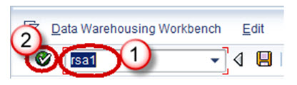

**Step 2)**

1. Navigate to Modelling tab->Info Provider.
2. Right click on Info Area.
3. Click on “Create Data Store Object” from the context menu.

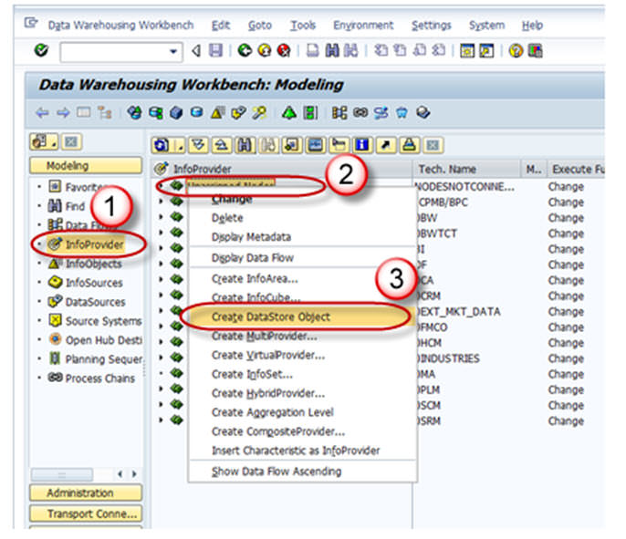

**Step 3)**

1. Enter the Technical Name.
2. Enter the Description.
3. Click on the “Create” button.

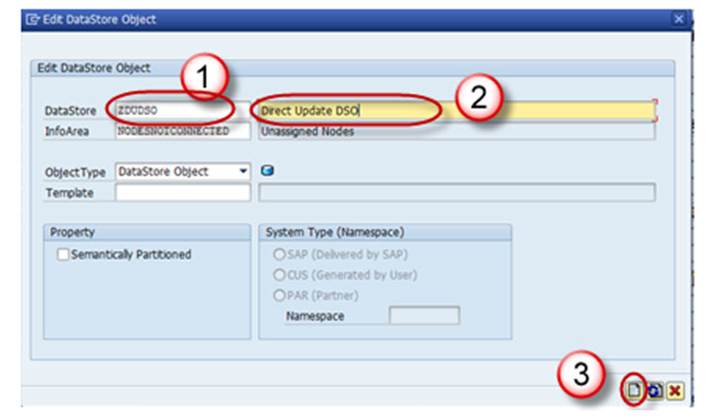

**Step 4)**

Click on the Edit button of “Type of DataStore Object”.

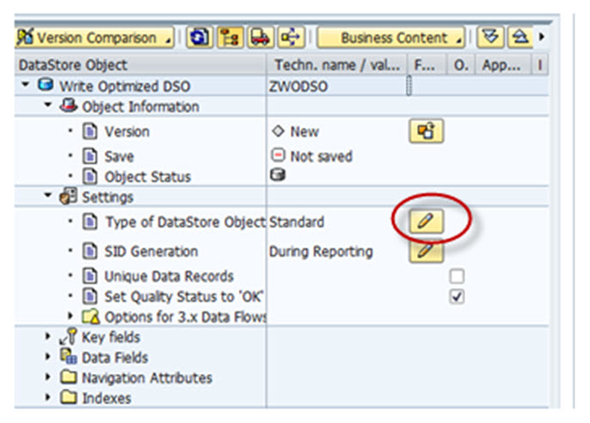

**Step 5)**

Choose the Type “Direct Update”.

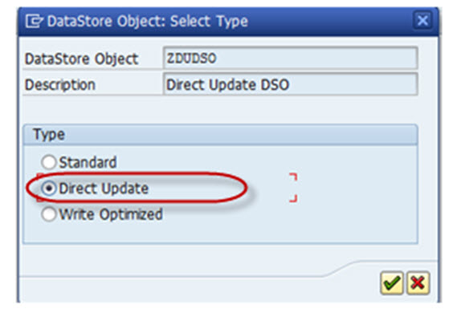

**Step 6)**

Activate the DSO.

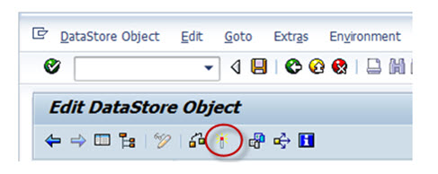

**What is InfoSet?**

**Details**

Last Updated: Sunday, 04 September 2016 16:00

Infoset is a special kind of Infoprovider which does not store data physically. In other words, Infoset are InfoProviders that logically join data and provide this data for BI queries. Infoset collects data from the tables of InfoProviders used to build it.  Infoset describes data sources that are defined as a rule of join on Datastore objects, Info-objects or standard InfoCubes.

**When to Use Infosets?**

* To join required data from basic InfoProviders
* To allow BEx Reporting on a DataStore object without turning the BEx Reporting indicator on
* To evaluate time dependencies
* To create self joins and left outer joins

**What are InfoSet Joins ?**

DSO ( Data Store Objects) and/or InfoObjects (characteristics with master data) are connected in the InfoSet using join conditions. The joined data from the InfoSets are available for access from Business Explorer Queries. InfoSets allows you to report on several Info-Providers (Infocubes, Data Store objects, master data InfoObjects), but they contain no data. With activated Infosets , you can define queries in the BI suite.

**Joins are classified into four categories:**

1. Inner Join
2. Left Outer Join
3. Temporal Join
4. Self Join

**Inner Join:**A record can only be in the selected result set if there are entries in both joined tables.

If table 2 has corresponding records of table 1, by comparing a key field (EMPNO in the below example), only those records would be part of the result set. The result set would have the fields of table 1 and table 2 filled in from the corresponding fields.

Example:

**Left Table(Table 1)**

|  |  |
| --- | --- |
| EMPNO | LASTNAME |
| 000020 | THOMPSON |
| 000250 | SMITH |
| 000100 | SPENSER |

**Right Table(Table 2)**

|  |  |
| --- | --- |
| EMPNO | PROJNO |
| 000020 | AD3112 |
| 000100 | OP2010 |
| 000150 | PL2100 |

**Inner Join Result**

|  |  |  |
| --- | --- | --- |
| EMPNO | LASTNAME | PROJNO |
| 000020 | THOMPSON | AD3112 |
| 000100 | SPENSER | OP2010 |

**Left Outer Join:**If table 2 has corresponding records of table 1, by comparing a key field (EMPNO in the below example), those records would be part of the result set. The result set would have the fields of table 1 and table 2 filled in from the corresponding fields.

If table 2 has no corresponding record when compared with table 1, those records of table 1 is also part of the result set (fields belonging to table 2 will have initial values). This is shown in the example below.

**Left Table(Table 1)**

|  |  |
| --- | --- |
| EMPNO | LASTNAME |
| 000020 | THOMPSON |
| 000250 | SMITH |
| 000100 | SPENSER |

**Right Table(Table 2)**

|  |  |
| --- | --- |
| EMPNO | PROJNO |
| 000020 | AD3112 |
| 000100 | OP2010 |
| 000150 | PL2100 |

**Left Outer Join Result**

|  |  |  |
| --- | --- | --- |
| EMPNO | LASTNAME | PROJNO |
| 000020 | THOMPSON | AD3112 |
| 000250 | SMITH |  |
| 000100 | SPENSER | OP2010 |

**Temporal Join:** A join is called temporal if at least one member is time-dependent.

**Self Join:** The same object is joined together.

**Creation Of Infoset:**

**Step 1)**

1. Go to Transaction Code RSA1
2. Click the “Ok” button

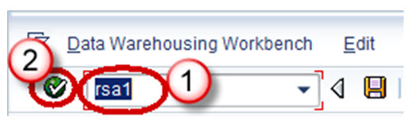

**Step 2)**

1. Browse to the tab “InfoProvider”
2. Right-Click on the infoarea and choose the option “Create Infoset” from the context menu.

Transaction RSISET can also directly be used to create InfoSet.

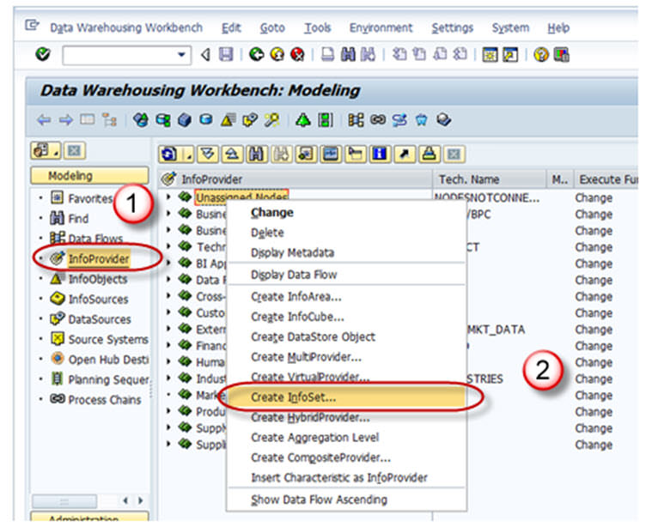

When the Info Set Builder is called for the first time, the below two display mode options as

1. Network (Dataflow Control)
2. Tree (Tree Control).

The network display is clearer.

The tree display can be read by the Screen Reader and is suitable for visually-impaired users.

You can change this setting at any time using the menu path Settings -> Display.

**Step 3)**

1. Enter the Technical Name
2. Description
3. In the *Start with Info Provider* section, you determine which Info Provider you want to use to start defining the Info Set. Select one of the object types that the system offers you:

* Data Store object
* Info Object
* Standard Info Cube
* Choose an object.

If you want to choose an Info Object, it must be a characteristic with master data. The system provides you with the corresponding input help.

1. Choose Continue button.

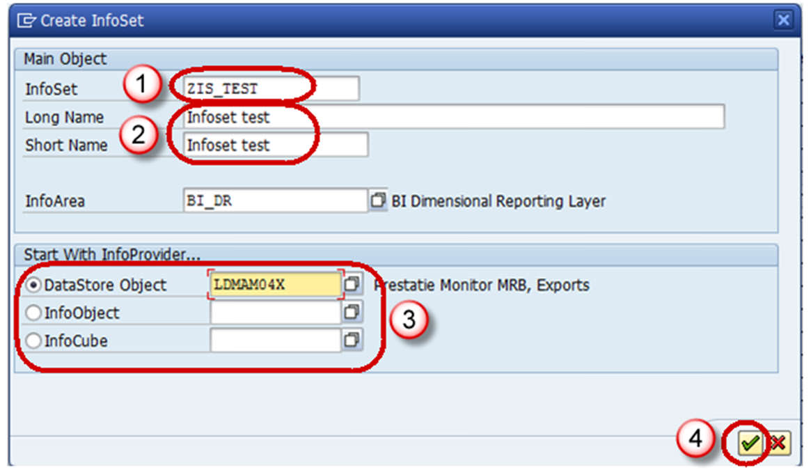

**Step 4)**

The *Change Info Set* screen appears.

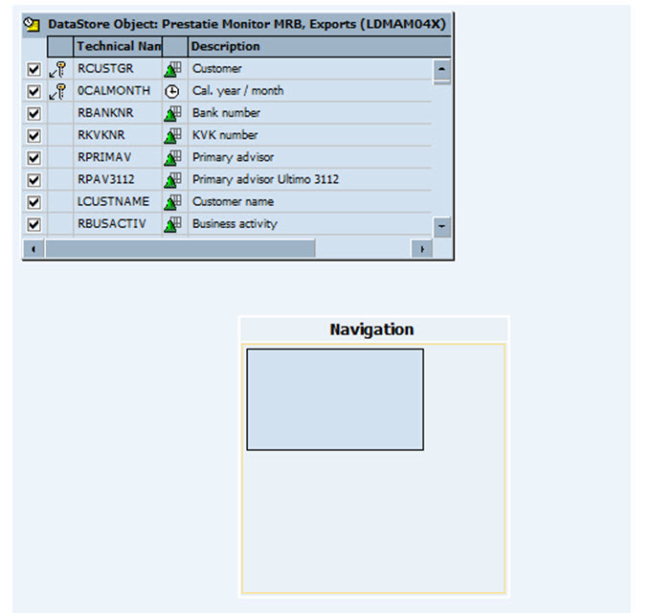

**Step 5)**

Select the insert Info provider button shown below, to choose the infoprovider with which data is to be joined.

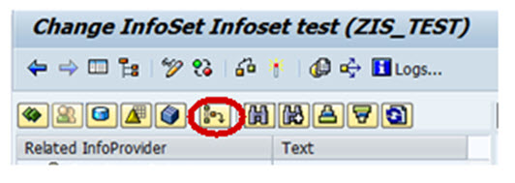

**Step 6)**

1. Enter the name of the DSO.
2. Click Continue button.

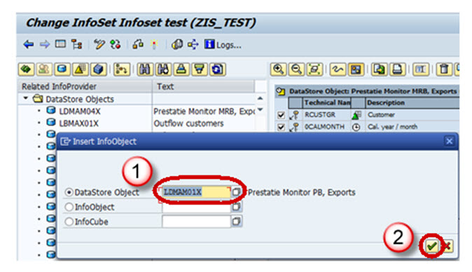

The below screen appears with the 2 info providers selected.

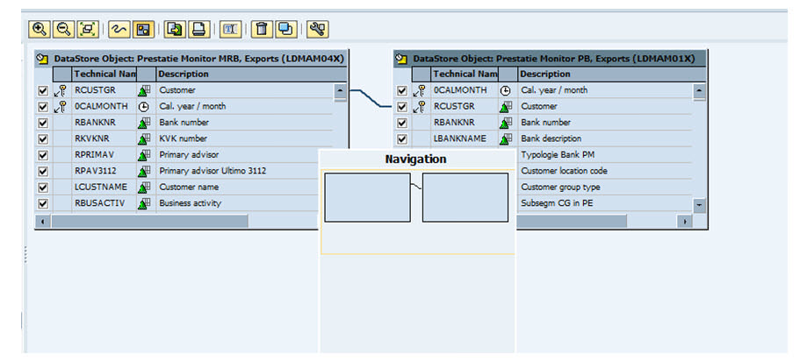

**Step 7)**

Activate the Info set by clicking on the activate button.

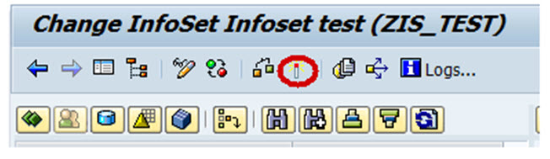

**What Is an Infocube? How To Create One?**

**Details**

Last Updated: Sunday, 04 September 2016 16:00

**What is Infocube?**

Infocube is data storage area in which we maintain data which we are extracting from source system physically.  An InfoCube can function as both a data target and an InfoProvider. From a reporting point of view, an Infocube can be described as a self-contained dataset.

For example, a Sales Amount Infocube which has dimensions like MONTH – PRODUCT-CUSTOMER-REGION, can be viewed by any of the axes, for example total sales by region or by customer. The dimensions of an Info-Cube are entities or hierarchies.

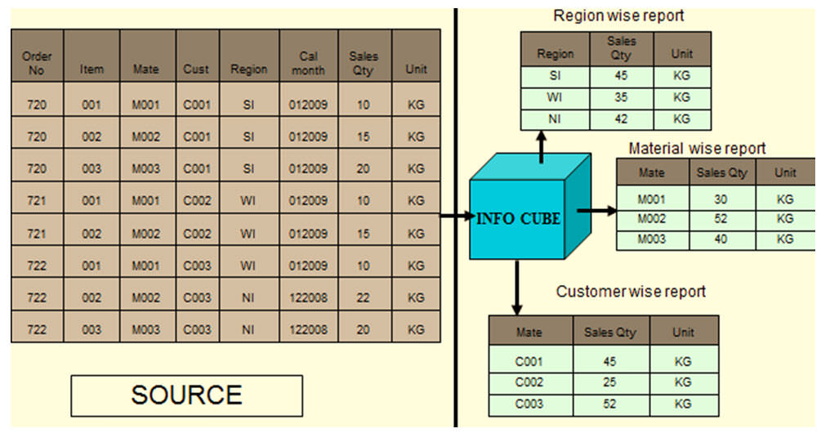

BIW ( Business Intelligence Warehouse) provides facility to define 16 dimensions, out of which 3 are pre-defined.

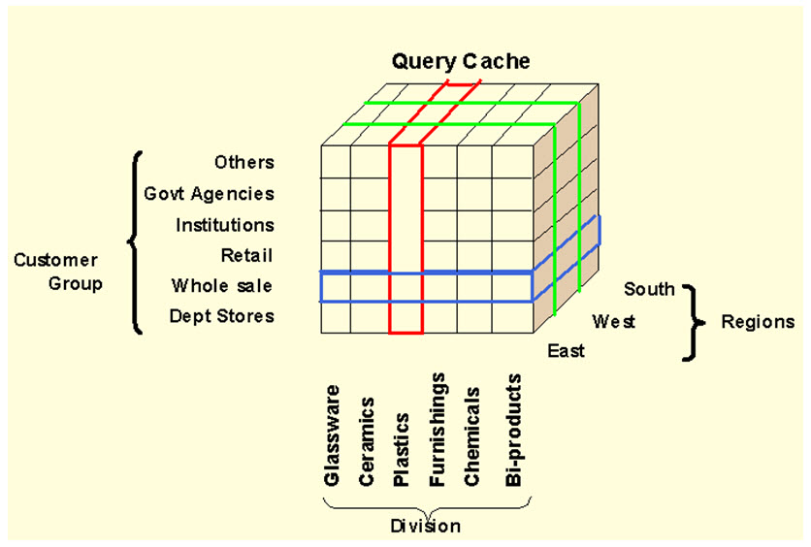

The above cube demonstrates a simple 3 dimensional cube. Each dimension can hold 248 characteristics for analysis. One square in the cube above, represents the relative value for the corresponding customer/region/division combination.

**InfoCube Structure:**

* An Infocube follows the Extended Star Schema.
* It has Fact table at the center and is surrounded by 16 dimension tables with Master data lying outside the cube.
* Infocubes are the central multidimensional data model in BI.
* It is a self-enclosed data set encompassing one or more related business processes. A reporting user can define or execute queries against an info cube.
* It is used to store summarized / aggregated data for long periods of time. Infocubes consist of precisely one fact table surrounded by dimensional tables.
* SAP delivered Infocubes begins with a number usually 0. Your own Infocube should begin with a letter from A to Z and that it should be 3 to 9 characters in length.

**Type of InfoCube**

Infocube is classified in to three types based on the way of maintaining and distributing the data.

* **Standard Infocube:**Used to maintain the data physically in the cube. Read only is possible.
* **Virtual Infocube:** It does not maintain data physically in the cube .During the query execution it brings the data from respective source system.
* **Real Time Infocube:** Stores the data physically in the cube.Read and Write are possible. It is significantly used in planning the data.

**How To Create  Standard Infocube**

**Step 1)**

Create InfoCube

1. Go to transaction code RSA1
2. Click the OK button.

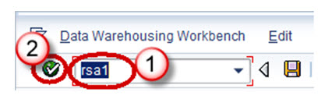

**Step 2)**

1. Navigate to Modeling tab->InfoProvider.
2. Right click on InfoArea.
3. Click on “Create InfoCube” from the context menu.

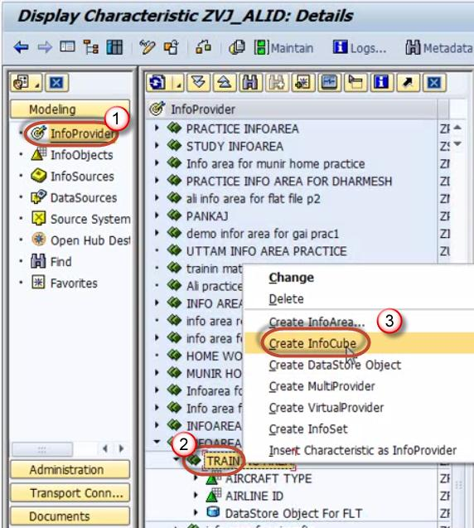

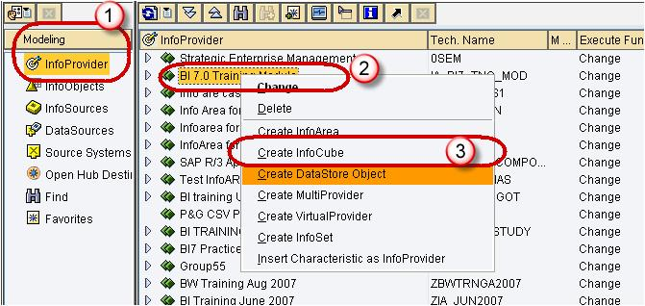

**Step 3)**

1. Enter the Technical Name.
2. Enter the Description.
3. Choose the option button “Standard InfoCube”.

Click the create button

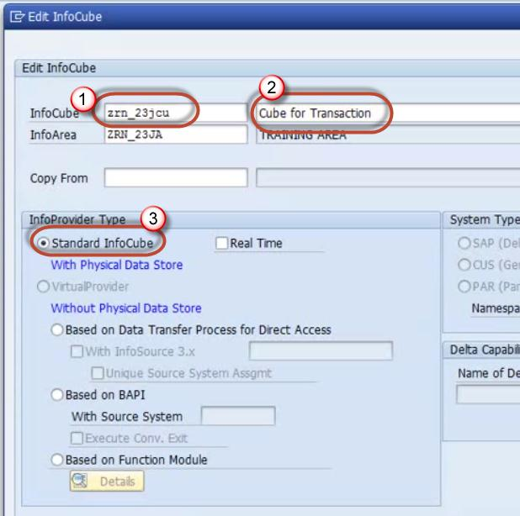

**Step 4)**

Right Click on Dimension 1 -> Properties.

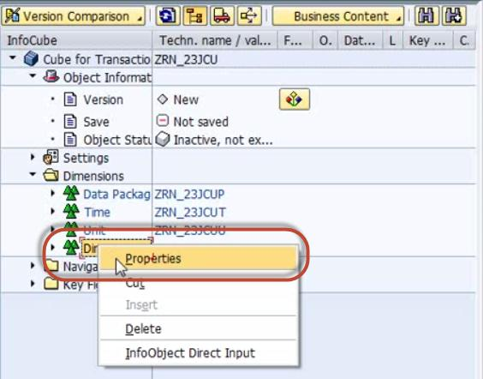

**Step 5)**

Rename the Dimension as per Info object information.

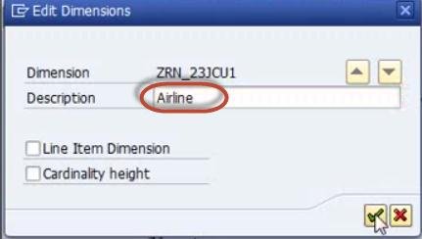

**Step 6)**

Right click on the Dimension ->InfoObject Direct Input to Insert InfoObjects into the Dimension.

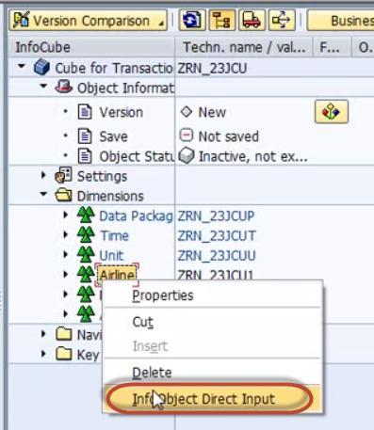

**Step 7)**

Select Characteristics.

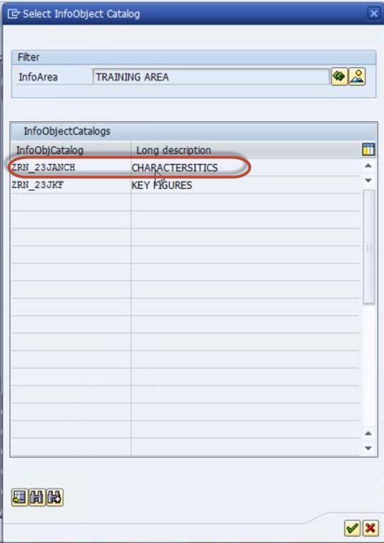

**Step 8)** Select Airline ID in characteristics

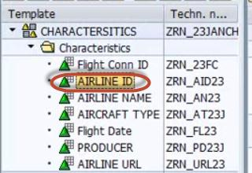

Drag and drop it into Dimension

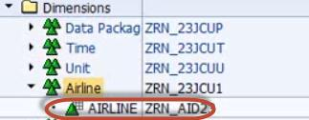

**Step 9)**

Similarly create new dimensions and follow the steps 4-8 to add the InfoObjects.

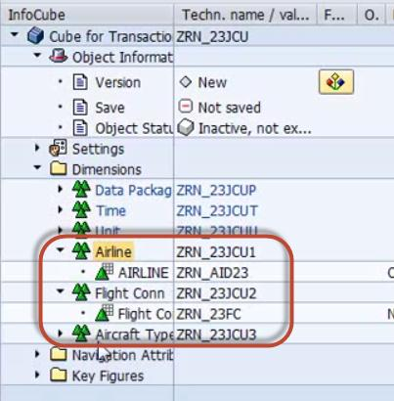

**Step 10)**

Adding Key figureInfoObjects in the Infocube

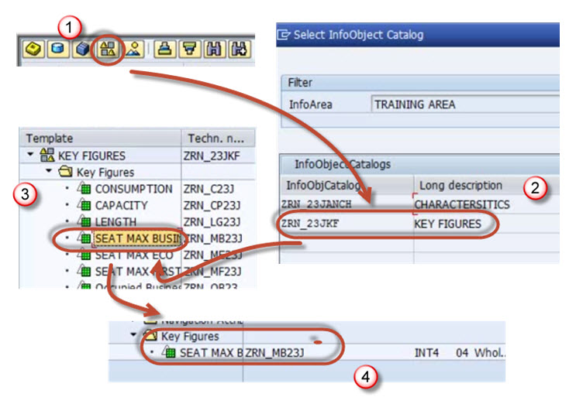

**Step 11)**

Follow the proesses above to add more Key Figures

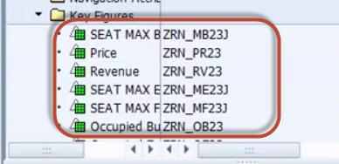

**Step 12)**

Activate the Infocube.

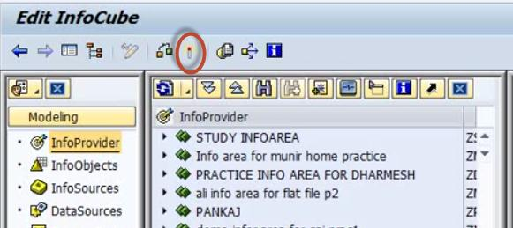

**Infocube Additional Points:**

The technical name of the dimensional table is assigned by the system, using the pattern /BIC/ “D<your Infocube>#”, where the first # will be a1, the second a 2, and so on*.*

If it is a sap delivered cube, then it would begin as /BI0/D

Characteristics Infoobjects can be freely added to customer-created dimensions.

Dimension Tables should be used optimally.

Ensure optimum cardinality while adding characteristics infoobject to dimensions.E.g. *A departmental store has 10,000 customers and 1000 different materials. The cardinality is* ***m:n****, which means each customer can buy many materials. Such kind of cardinality should not be maintained in the same dimension table.*

*Thumbrule : Avoid m:n within a dimension.*

**Dos**

* Navigate to Modeling tab->InfoProvider.
* Right click on InfoArea.
* Click on “Create InfoCube” from the context menu.
* Enter the Technical Name.
* Enter the Description.
* Choose the option button “Standard InfoCube”.

**Don’ts**

* Standard Infocube can be used if user:
* Wants to facilitate multi-dimensional analysis.
* Wants to store summarized / aggregated information with large volume of data.
* Use line item dimension if only one object is placed in a dimension table.
* Maintain high granularity of records.
* Group M: N cardinality within the same dimension.
* Give more attention on bring the character information through navigational attribute.
* Maintain high cardinality information in dimensional table.

**How To Load Master Data From Flat File?**

**Details**

Last Updated: Sunday, 04 September 2016 16:00

**We will learn the load with the help of a scenario -**

Load Master data to InfoObject ZMAT (Material Number) which has the attribute, ZMAT_NM (Material Name. Below are detailed Steps to Load data to Master data Infoobject from Flat file

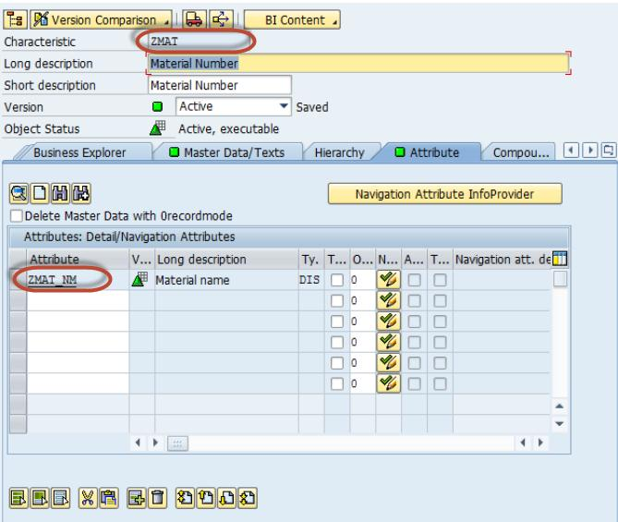

**Step 1)  Create source system for flat file**.

1. Go to transaction code RSA1
2. Click the OK button.

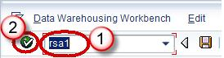

In the next screen,

1. Navigate to Modeling tab->Source Systems.
2. Right click on the folder named FILE and choose “Create” from the context menu.

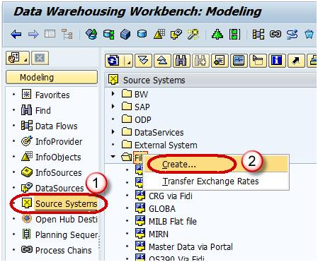

In the next screen,

1. Enter the Logical System Name.
2. Enter the Description.
3. Click Continue Button.

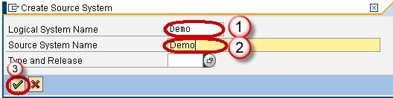

**Step 2) Create Application component.**

1. Navigate to Modeling tab->Data Sources.
2. Choose the Source System.

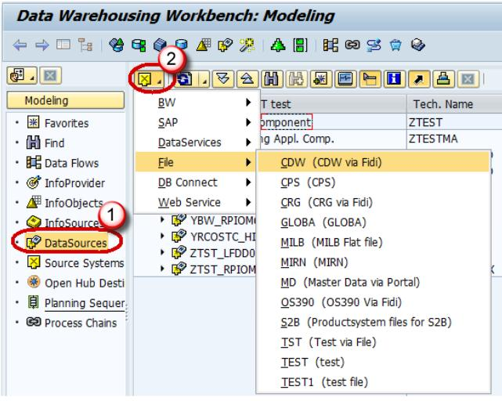

1. Right click -> Create Application Component.

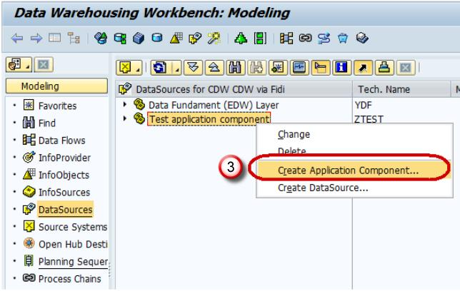

1. Enter the Technical Name.
2. Enter the Description.
3. Click Continue.

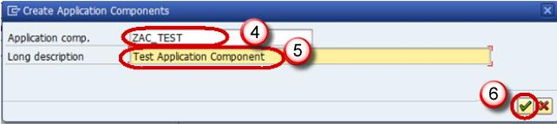

1. Navigate to Modeling tab->Data Sources.
2. Right click -> Create Data Source

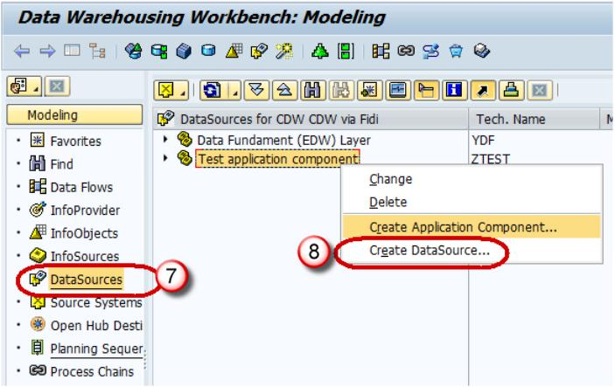

1. Enter Technical Name.
2. Choose the DataType DataSource.
3. Click Continue.

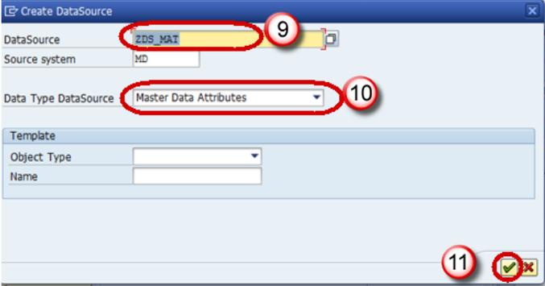

1. Enter the Fields shown below. This Structure should be the same as the DSO to which transaction data is to be loaded.

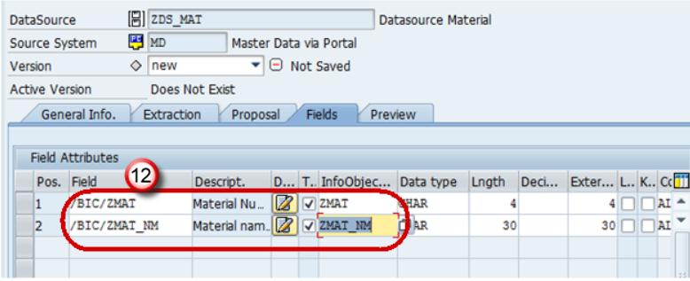

1. In the Extraction tab, choose the Adapter as “Load Text-Type File from Local Workstation”.
2. Choose the file path where the flat file to be loaded is placed in the system and activate data source.

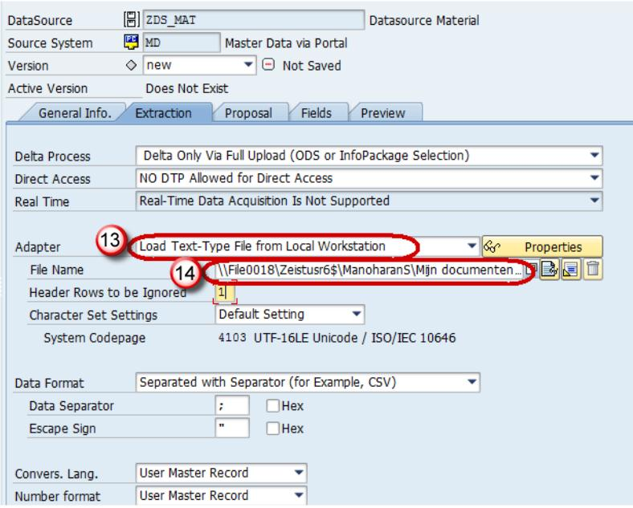

Click Save.

**Step 3) Create transformation between Data Source(Source) and InfoObject Attribute(Target).**

Right click on the DataSource -> Create Transformation

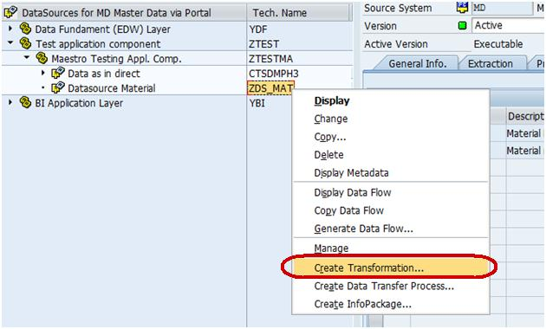

In the next screen,

1. Enter Target Object Type.
2. Enter Target Object Name.
3. Enter the SubType
4. Click Continue.

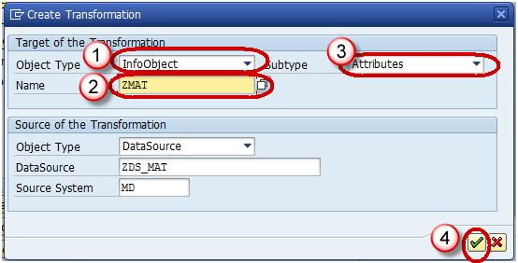

The transformation would be created with automatic mapping of the Source fields to the Target fields.

Right-Click on DTP folder and choose the option “Create Data Transfer Process” from the context menu.

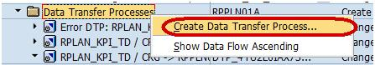

Below screen shows the DTP created.

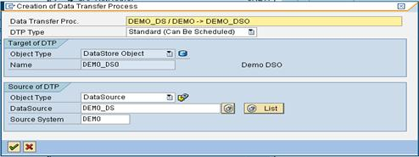

**Step 4) Create Infopackage and Schedule dataload to the DataSource(PSA).**

1. Enter RSA1 in command prompt
2. Hit Enter
3. Navigate to Modeling tab->DataSources.
4. Right click on the DataSource -> Create InfoPackage.

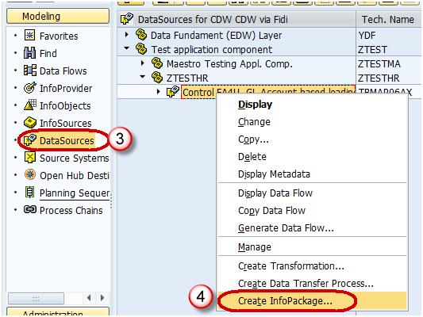

1. Enter the InfoPackage Description
2. Click Save.

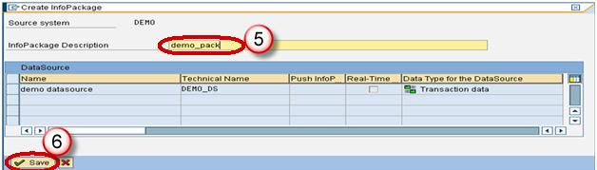

1. Click on Schedule tab.
2. Click Start button to start the load from the flat file to the Data Source.

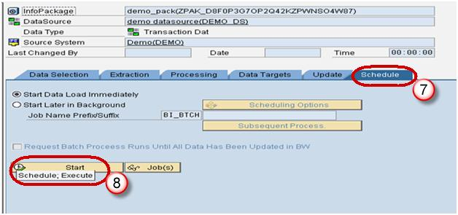

**Step 5) Load data to the DSO.**

1. Click Execute tab in the DTP.
2. Click the Execute Button to start data load from the DataSource(PSA) to the DSO.

